

FACULTY OF TECHNOLOGY AND ENGINEERING DEVANG PATEL INSTITUTE OF ADVANCE TECHNOLOGY AND RESEARCH

DEPARTMENT OF COMPUTER ENGINEERING

A.Y 2026 – 27 Semester – 3

LAB MANUAL

CSUC201 Fundamentals of Data Structures and Algorithms



Practical 4: Singly Linked List: Dynamic Insertion, Deletion, and Traversal

Problem 1 A hospital manages a queue of patient tokens. New critical patients must be added to the front, routine patients are added to the end, and occasionally a patient with a priority number must be inserted at a specific position in the queue. Given a sequence of such operations, implement all three insertion types and print the final queue after each operation. Describe how your insertion at a specific position works. What does your solution do if the position given is greater than the current length of the queue? Is that handled explicitly or does it cause an error?

For code :

https://github.com/kvvaghasiya49/FDSA/tree/6fb2f463bf1f58ac 408ada5ca8ffdaa64bc82087/DSA

OutPut :

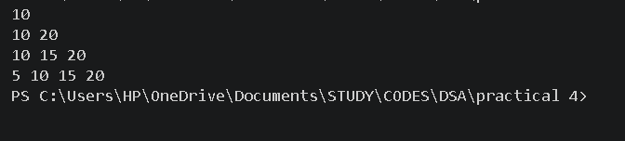

Problem 2 The hospital also needs to remove a patient token from the queue when a patient leaves, print all remaining tokens from last to first for an end-of-day audit, and display the full queue from front to back at any point. Implement deletion by value, reverse printing, and forward traversal on the same queue from Problem 4.1a. Describe how your reverse printing works. Does it use any extra storage, or does it work purely by following the links? Can you think of another way to reverse-print without modifying the original queue?

For code :

https://github.com/kvvaghasiya49/FDSA/tree/6fb2f463bf1f58ac 408ada5ca8ffdaa64bc82087/DSA

Output :

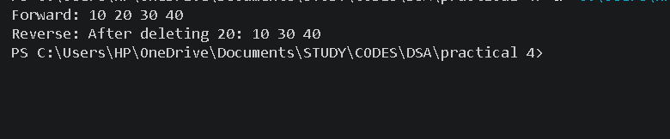

Challenges Faced:
At first, inserting at a specific position was confusing because I had to stop at the node just before that position and change two links in the correct order. When I changed the links in the wrong order, the rest of the list got lost. I also had to handle special cases separately, like inserting into an empty list and giving a position greater than the length of the queue. In deletion by value, the hardest cases were deleting the first node, where the head pointer itself has to change, and deleting the only node, where the head must become NULL. For reverse printing, I could not go backward because a singly linked list has only one link per node. I solved it using recursion, which prints the remaining list first and then prints the current node while coming back. It took me some time to understand how the recursion calls work.

Learning Outcomes:
- I learned how to insert a node at the front, at the end, and at a specific position by changing links in the correct order.
- I understood that edge cases like an empty list, a single node, or an invalid position must be checked before doing the operation, otherwise the program can crash.
- I learned that deleting the first node or the only node is different from deleting a middle node, because the head pointer has to be updated.
- I learned that a singly linked list can only move forward, and that reverse printing can be done using recursion without changing the original list.
- This helped me understand how pointers connect nodes in memory, and why tracing the links step by step on paper makes debugging much easier.

1. Inserting at a position beyond the current length of the list is an invalid operation. Should your solution silently insert at the end, report an error, or do something else entirely? Justify your choice and explain what assumption about the caller your choice makes.

Ans :
My solution reports an error message and does not insert anything when the position is greater than the length of the queue (+1 for the end). I chose this because silently inserting at the end would hide the mistake. The patient would be placed at a position the caller never asked for, and the caller would not know about it. In a hospital queue, a wrong position could mean a priority patient is placed incorrectly without anyone noticing. Reporting an error keeps the list safe and tells the caller that the input was wrong.
This choice assumes that the caller knows the current length of the queue and is responsible for giving a valid position. If the caller wants to add at the end, they should use the insert at end operation instead.

2.If the node to be deleted is the only node in the list, how many pointers need to change and what must they be set to? How is this case structurally different from deleting a node in the middle?

Ans :
If the node to be deleted is the only node, only one pointer needs to change. The head pointer must be set to NULL, because there is no node left in the list. After that, the node's memory is freed.
This is different from deleting a middle node. In the middle case, the head pointer does not change. Instead, the next pointer of the previous node must be changed to point to the node after the deleted node, so the list stays connected. In the only-node case, there is no previous node and no next node, so there is nothing to connect and the list simply becomes empty. The key difference is that the only-node (and first-node) case changes the head pointer, while the middle case changes the previous node's link.

Remarks :

